**Code changes done in the myTraining Project**

**Servlet(Java):**

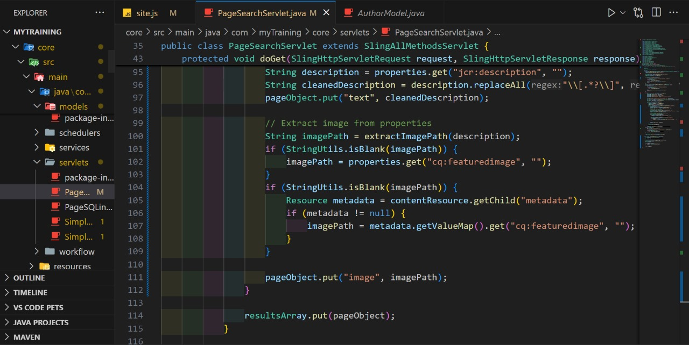

**AuthorModel.java**

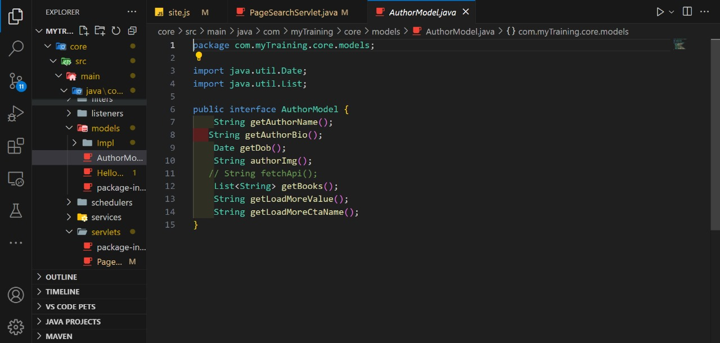

**Book.java**

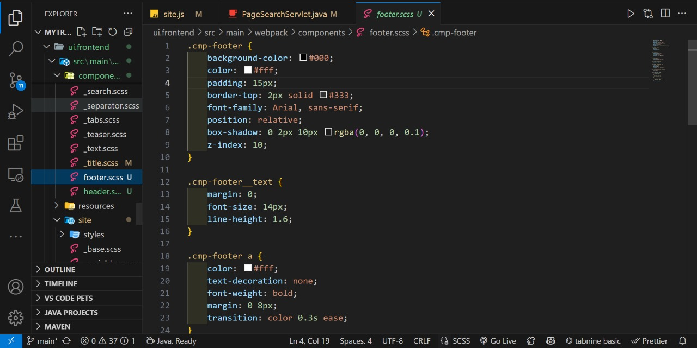

**CSS styling:**



